David Arthur Band Biography:

The David Arthur Band has been thrilling audiences nationwide for over 15 years. David Arthur is a graduate of the prestigious Northern Colorado Jazz Studies program, and began playing professionally right out of college. In 1996 he organized his seven piece swing band "The Round Table Band". The band was an immediate success, playing shows in New Mexico, Nebraska, Chicago, California, and all over the U.S. The Round Table Band released it’s first self titled album in 1998, which furthered their success and notoriety .The Round Table Band also spent a year on Carnival Cruise lines, playing shows to audiences from around the globe. The Round Table Band captures the big band sound audiences love, but with a more intimate style and size.

In 2006, David began focusing on playing Jazz with smaller ensembles, and this work culminated in the release of his most recent album “Loud Mouth” in 2008. David performs all over Colorado with both his quartet and his seven piece band. His latest album can be heard on KUVO, the nation's premiere Jazz station.

David’s voice has been compared to the great crooners of yesteryear, such as Frank Sinatra and Mel Torme. His smooth seductive voice, subtle wit and style make him the ideal front man for any occasion, from casual, to very elegant.

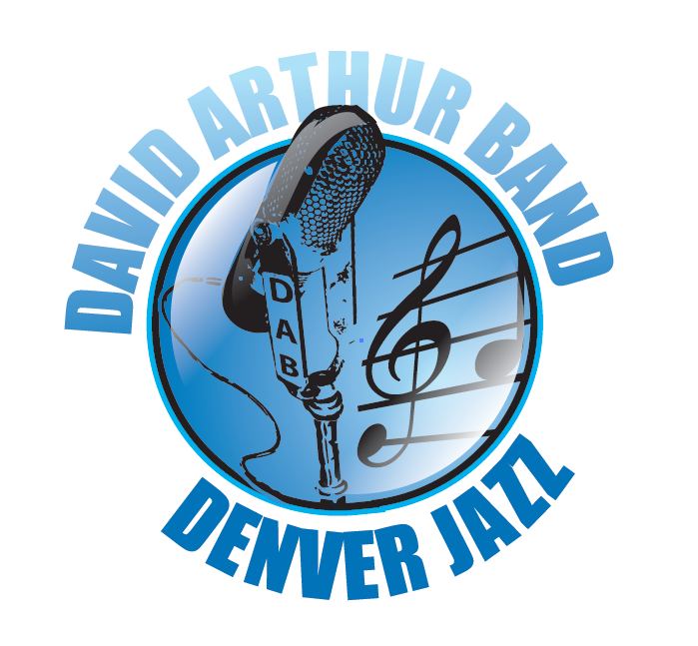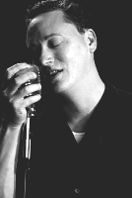

Hear Music, get promo materials and downloads at www.davidarthurband.com.

